National University of Sciences and Technology

School of Electrical Engineering and Computer Science

Department of Electrical Engineering

|  |  |
| --- | --- |
| **EE-421: Digital System Design** | |
| **Faculty Member** | **Semester** |
| Dr. Rehan Ahmed | 6th |
| **Class/Section** | **Date** |
| BEE11 | 21st May 2022 |

**Assignment 2**

|  |  |
| --- | --- |
| **Name** | **Registration No.** |
| Ali Hamza Malik | 291480 |
| Muhammad Shayan Nazeer | 292241 |

## Screenshots:

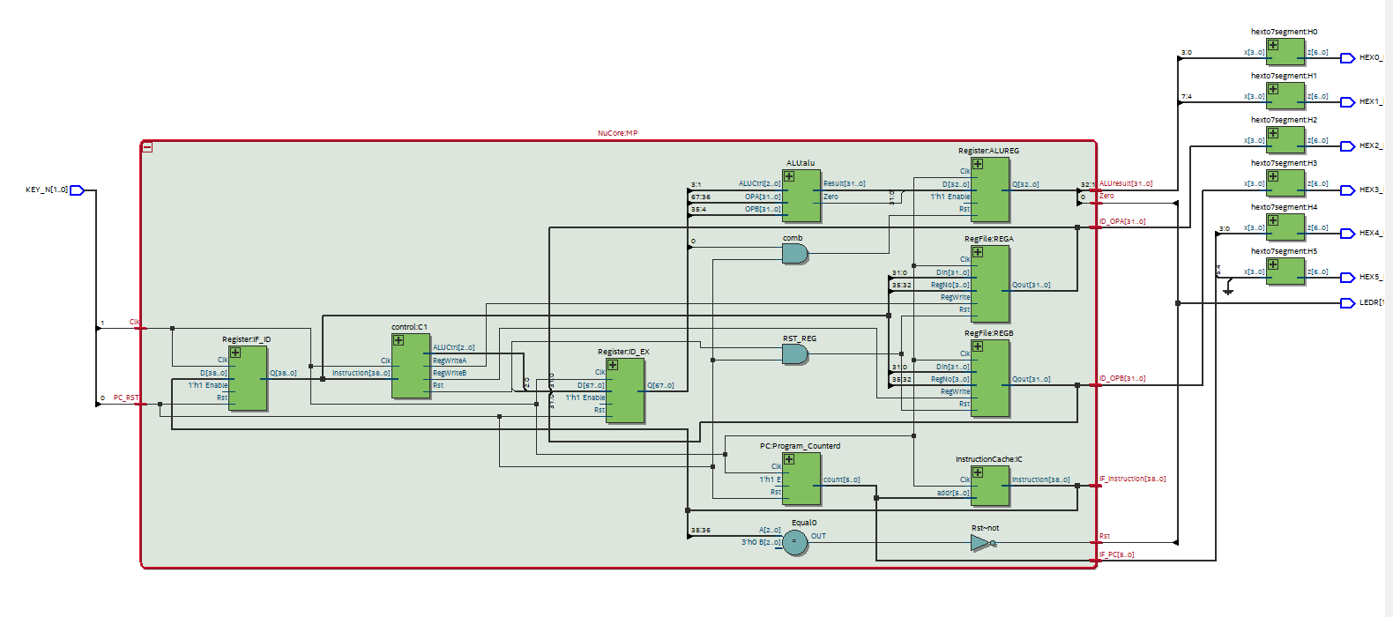

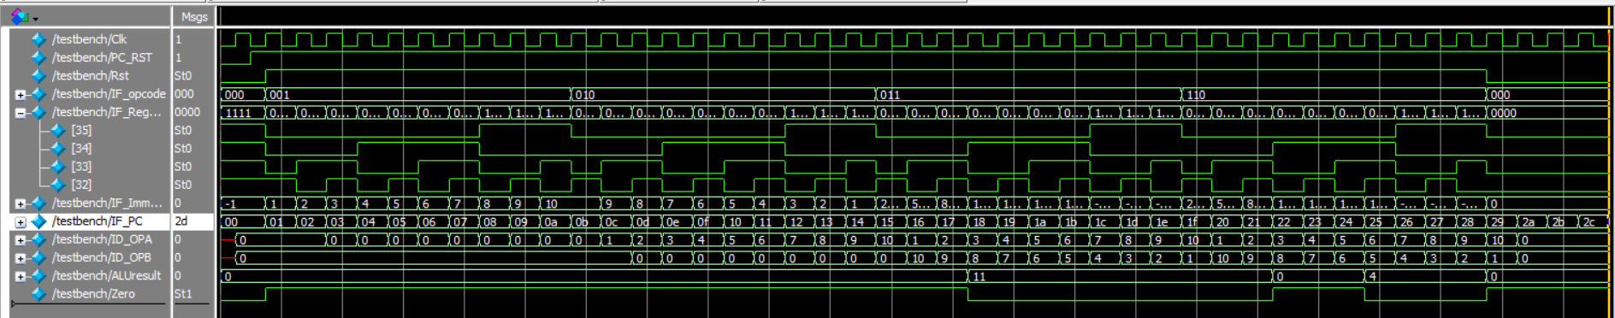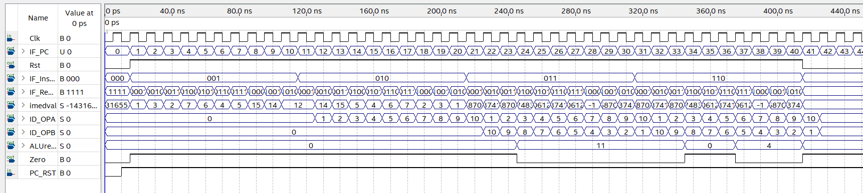



## Code:

module top(KEY_N,LEDR,HEX0_N,HEX1_N,HEX2_N,HEX3_N,HEX4_N,HEX5_N);

//top module to interface MicroProcessor with FPGA I/O

input [1:0]KEY_N;

output [1:0]LEDR;

output [6:0]HEX0_N,HEX1_N,HEX2_N,HEX3_N,HEX4_N,HEX5_N;

wire Clk;

wire [38:0] IF_Instruction;

wire [31:0]ID_OPA,ID_OPB,ALUresult;

wire [5:0] IF_PC;

wire Zero,Rst,PC_RST;

assign Clk=KEY_N[1];//attach clock to key_1

assign PC_RST=KEY_N[0];//attach PC_RST to key_0

NuCore MP(Clk,PC_RST,Rst,IF_PC,IF_Instruction,ID_OPA,ID_OPB,ALUresult,Zero);//instantiating Pipelined MicroProcessor

//displaying ALUResult on HEX0 and HEX1

hexto7segment H0(ALUresult[3:0],HEX0_N);

hexto7segment H1(ALUresult[7:4],HEX1_N);

hexto7segment H2(ID_OPA[3:0],HEX2_N);

hexto7segment H3(ID_OPB[3:0],HEX3_N);

hexto7segment H4(IF_PC[3:0],HEX4_N);

hexto7segment H5({2'b00,IF_PC[5:4]},HEX5_N);

assign LEDR[0]=Zero;//attach zero flag to LEDR0

assign LEDR[1]=Rst;//attach Reset flag to LEDR1

endmodule

//PipelinedMP

module NuCore (Clk,PC_RST,Rst,IF_PC,IF_Instruction,ID_OPA,ID_OPB,ALUresult,Zero);

parameter n=32;//32 bit datawidth

input Clk,PC_RST;//input signals

//output signals for running testbench and confirming outputs

output [38:0] IF_Instruction;

output [n-1:0]ID_OPA,ID_OPB,ALUresult;

output [5:0] IF_PC;

output Zero,Rst;

//////////////////////////////////////////////////////////////////////////////////////////////////////

//(Instruction Fetch) IF Stage

PC Program_Counterd(Clk,PC_RST,1'b1,IF_PC);//PC counter in IF stage

InstructionCache IC(Clk,IF_PC,IF_Instruction);//PC counter in IF stage

//////////////////////////////////////////////////////////////////////////////////////////////////////

//////////////////////////////////////////////////////////////////////////////////////////////////////

//IF_ID Pipline REG

wire IF_Rst;

assign Rst=IF_Rst;

assign IF_Rst=IF_Instruction[38:36]!=3'b000;

wire [38:0] ID_Instruction;

Register IF_ID(Clk,PC_RST,1'b1,{IF_Instruction},{ID_Instruction});

defparam IF_ID.N=39;

//39+1=39

//////////////////////////////////////////////////////////////////////////////////////////////////////

//////////////////////////////////////////////////////////////////////////////////////////////////////

//(Instruction Decode + Write Stage) ID+W Stage

wire ID_Rst;

wire RegWriteA,RegWriteB;

wire [3:0]RegNo;

wire [2:0]ID_ALUCtrl;

control C1(Clk,ID_Rst,ID_Instruction,RegWriteA,RegWriteB,ID_ALUCtrl);

wire RST_REG;

assign RST_REG=ID_Rst & PC_RST;

RegFile REGA(Clk,RST_REG,RegWriteA,ID_Instruction[35:32],ID_Instruction[31:0],ID_OPA);

RegFile REGB(Clk,RST_REG,RegWriteB,ID_Instruction[35:32],ID_Instruction[31:0],ID_OPB);

//////////////////////////////////////////////////////////////////////////////////////////////////////

//////////////////////////////////////////////////////////////////////////////////////////////////////

//(ID+W)_EX Pipline REG

wire [2:0]EX_ALUCtrl;

wire [n-1:0] EX_OPA,EX_OPB,EX_ALUresult;

wire EX_Rst,EX_Zero;

Register ID_EX(Clk,PC_RST,1'b1,{ID_OPA,ID_OPB,ID_ALUCtrl,ID_Rst},{EX_OPA,EX_OPB,EX_ALUCtrl,EX_Rst});

defparam ID_EX.N=68;

//32+32+3+1=68

//////////////////////////////////////////////////////////////////////////////////////////////////////

//////////////////////////////////////////////////////////////////////////////////////////////////////

//(Execute)EX Stage

ALU alu(EX_OPA,EX_OPB,EX_ALUCtrl,EX_ALUresult,EX_Zero);

//////////////////////////////////////////////////////////////////////////////////////////////////////

//ALU Pipline REG

Register ALUREG(Clk,PC_RST,1'b1,{EX_ALUresult,EX_Zero},{ALUresult,Zero});

defparam ALUREG.N=33;

//////////////////////////////////////////////////////////////////////////////////////////////////////

endmodule

//REGISTER MODULE to be used for PIPELINING REGISTER's

module Register(Clk,Rst,Enable,D,Q);

parameter N=32;

input Clk,Rst,Enable;

input [N-1:0]D;

output reg[N-1:0]Q;

always@(posedge Clk,negedge Rst)begin

if(!Rst)Q<=0;

else if(Enable)Q<=D;

else Q<=Q;

end

endmodule

module hexto7segment(input [3:0]x,output reg [6:0]z);//7 segment hex decoder to display results

always @(x)

case (x)

4'h0 : z = 7'b1000000;

4'h1 : z = 7'b1111001;

4'h2 : z = 7'b0100100;

4'h3 : z = 7'b0110000;

4'h4 : z = 7'b0011001;

4'h5 : z = 7'b0010010;

4'h6 : z = 7'b0000010;

4'h7 : z = 7'b1111000;

4'h8 : z = 7'b0000000;

4'h9 : z = 7'b0010000;

4'hA : z = 7'b0001000;

4'hB : z = 7'b0000011;

4'hC : z = 7'b1000110;

4'hD : z = 7'b0100001;

4'hE : z = 7'b0000110;

4'hF : z = 7'b0001110;

default:z= 7'b1111111;

endcase

endmodule

module RegFile(Clk,Rst,RegWrite,RegNo,Din,Qout);

//module for Regfile to be used for REGA and REGB

parameter n=32,widthbit=4;

input Clk,Rst,RegWrite;

input [widthbit-1:0]RegNo;

input [n-1:0]Din;

output [n-1:0]Qout;

reg [n-1:0]RF [(2**widthbit)-1:0];

integer k;

always@(posedge Clk)begin

if(!Rst)begin

for(k=0;k<2**widthbit;k=k+1)RF[k]<=0; //setting all registers to 0 when reset

end

else if(RegWrite)begin

RF[RegNo]<=Din;

end

end

assign Qout=RF[RegNo];

endmodule

module InstructionCache(Clk,addr,Instruction);

parameter DATA_WIDTH=39, ADDR_WIDTH=6;

input Clk;

output [(DATA_WIDTH-1):0] Instruction;

input [(ADDR_WIDTH-1):0] addr;

//instantiating ram module for Instruction Cache

// which Reads and assigs initial values to RAM from "instruction1.txt" file

RAM ram1(

{(DATA_WIDTH){1'b0}},

addr,

1'b0,

Clk,

Instruction

);

endmodule

//RAM module created by modifiying ram template from quartusus

module RAM

#(parameter DATA_WIDTH=39, parameter ADDR_WIDTH=6)

(

input [(DATA_WIDTH-1):0] data,

input [(ADDR_WIDTH-1):0] addr,

input we, Clk,

output [(DATA_WIDTH-1):0] q

);

// Declare the RAM variable

reg [DATA_WIDTH-1:0] ram[(2**ADDR_WIDTH)-1:0];

// Specify the initial contents. You can also use the $readmemb

// system task to initialize the RAM variable from a text file.

// See the $readmemb template page for details.

initial

begin : INIT

$readmemb("instructions1.txt", ram);//Reading and assiging initial values to RAM from "instruction1.txt" file

end

always @ (posedge Clk)

begin

// Write

if (we)

ram[addr] <= data;

end

// Continuous assignment implies read returns NEW data.

// This is the natural behavior of the TriMatrix memory

// blocks in Single Port mode.

assign q = ram[addr];

endmodule

module ALU(OPA,OPB,ALUCtrl,Result,Zero);

//module for ALU which decodes instruction directly from 3 bit instruction

parameter n=32;

input [2:0]ALUCtrl;

input [n-1:0]OPA,OPB;

output reg [n-1:0]Result;

output Zero;

assign Zero=(Result==0);

always@(*)begin

case(ALUCtrl)

3'b011:Result=OPA + OPB;

3'b100:Result=OPA - OPB;

3'b101:Result=OPA | OPB;

3'b110:Result=OPA & OPB;

3'b111:Result=OPA<<OPB;

default:Result=0;

endcase

end

endmodule

module PC(Clk,Rst,E,count);

//simple counter accting as Program counter

input Clk,Rst,E;

output reg [5:0] count;

always@(posedge Clk,negedge Rst)begin

if(!Rst)count<=0; //set count to 0 on

else if(E) count<=count+6'b000001;

else count<=count;

end

endmodule

module control(Clk,Rst,Instruction,RegWriteA,RegWriteB,ALUCtrl);

//control unit to decode instruction and generate required control signals

input Clk;

input [38:0] Instruction;

output RegWriteA,RegWriteB,Rst;

output [2:0]ALUCtrl;

assign Rst=(Instruction[38:36]!=3'b000);

assign RegWriteA=(Instruction[38:36]==3'b001);

assign RegWriteB=(Instruction[38:36]==3'b010);

assign ALUCtrl=Instruction[38:36];

endmodule

## TestBench:

`timescale 1 ps/ 1 ps

module testbench();

// constants

// general purpose registers

reg Clk;

reg PC_RST;

// wires

wire [31:0] ALUresult;

wire [31:0] ID_OPA;

wire [31:0] ID_OPB;

//wire [38:0] IF_Instruction;

wire [38:36]IF_opcode;

wire [35:32]IF_RegAddress;

wire [31:0]IF_Immedval;

wire [5:0] IF_PC;

wire Rst;

wire Zero;

// NuCore module assignment

NuCore NuCore_TB(

.ALUresult(ALUresult),

.Clk(Clk),

.ID_OPA(ID_OPA),

.ID_OPB(ID_OPB),

.IF_Instruction({IF_opcode,IF_RegAddress,IF_Immedval}),

.IF_PC(IF_PC),

.PC_RST(PC_RST),

.Rst(Rst),

.Zero(Zero)

);

initial

begin

#1000000 $stop;

end

// Clk

always

begin

Clk = 1'b0;

Clk = #5000 1'b1;

#5000;

end

// PC_RST

initial

begin

PC_RST = 1'b0;

PC_RST = #10000 1'b1;

//PC_RST = #400000 1'b0;

//PC_RST = #10000 1'b1;

end

endmodule